# High-Level Design (HLD)

# E-commerce Dashboard

Revision Number: 1.0

Last date of revision: 30/08/2021

Mayank Rai

**Document Version Control**

|  |  |  |  |
| --- | --- | --- | --- |
| **Date Issued** | **Version** | **Description** | **Author** |
| **30th August 2021** | 1.0 | First Version of Complete HLD | Mayank Rai |
|  |  |  |  |
|  |  |  |  |
|  |  |  |  |
|  |  |  |  |
|  |  |  |  |
|  |  |  |  |

[AUTHOR NAME]

## Contents

High-Level Design (HLD) 1

E-commerce Dashboard 1

Contents 3

1 Introduction 4

1.2 Scope 4

3 Design Details 5

3.1 Functional Architecture 5

4 KPIs 9

4.1 KPIs (Key Performance Indicators) 9

5 Deployment 9

Pros 10

Cons 10

## 1 Introduction

**1.1 Why this High-Level Design Document?**

The purpose of this High-Level Design (HLD) document is to add the necessary detail to the current project description to represent a suitable model for coding. This document is also intended to help detect contradictions before coding and can be used as a reference manual for how the modules interact at a high level.

The HLD will:

• Present all of the design aspects and define them in detail

• Describe the user interface being implemented

• Describe the hardware and software interfaces

• Describe the performance requirements

• Include design features and the architecture of the project

• List and describe the non-functional attributes like:

o Security

o Reliability

o Maintainability

o Portability

o Reusability

o Application compatibility

o Resource utilization

o Serviceability

### 1.2 Scope

The HLD documentation presents the structure of the system, such as the database architecture, application architecture (layers), application flow (Navigation), and technology architecture. The HLD uses non-technical to mildly-technical terms which should be understandable to the administrators of the system.

## 3 Design Details

### 3.1 Functional Architecture

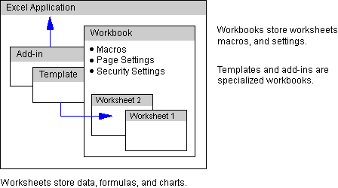

**Workbooks**

The workbook in Excel is analogous to the document in Microsoft Word, or the presentation in Microsoft PowerPoint. The workbook stores data in the Excel file format. Excel workbook files have the extension .xls (Windows) or the file type Excel Document (Macintosh).

The various components of Excel, such as cell data and formulas, are stored in the workbook file. Some components, such as cell data and charts, are stored on worksheets in the workbook. Other components, such as macros, book­level security settings, and page settings, are stored in the workbook file but not on worksheets.

**Cell Data**

Cell data consists of constant values stored in cells and can be either of the following:

* Numeric values, including date, time, currency, percentage, or scientific notation
* Text

The way Excel displays numeric values in a cell depends on the number format assigned to a cell. The numeric value displayed may differ from the actual value Excel stores, which is with 15 digits of accuracy. By default, Excel makes calculations based on the stored value. Such calculation is known as *full precision* calculation. However, you can have Excel calculate based on displayed values. To do this type of calculation, click **Options** (Windows) or **Preferences** (Macintosh) on the **Tools** menu, click the **Calculations** tab, and then select **Precision as displayed**.

Calculating with precision as displayed does the following:

* Affects all worksheets in the active workbook.
* Does not affect numbers in the General format, which are always calculated with full precision.
* Slows calculation because Excel must round the numbers as it calculates.

**Caution**Once you switch to calculating on displayed values, Excel stores all constant values as their displayed values and full precision values cannot be restored.

**Cell Formulas**

Formulas use cell references when performing calculations on your data, and are part of the data that is stored in the workbook. Cell references in a formula can be relative, absolute, or mixed references in any of the following reference styles:

* A1 style
* Row ­and ­column (R1C1) style
* Name references

Both A1 and row­and­column reference styles refer to data by position. Using these styles, you may experience difficulty with formulas if you reposition or delete cells. One way to avoid this problem is to reference cells by name.

**Name References**

You can use a name as a reference to a cell, a group of cells, a value, or a formula. Name references can be accessible to an entire workbook or restricted to a worksheet. When a name reference is restricted to a worksheet, it can be repeated on more than one sheet so that it defines related cells on different sheets in the same workbook. A book­level name reference, on the other hand, cannot be repeated on more than one worksheet. Instead, it can be used throughout the workbook to refer to cells on one worksheet. Using book­level names eliminates the need to recreate names for each new worksheet or to type worksheet references in formulas. Sheet­level names override book­level names when used on the sheet where they are defined.

To use book­level name references, you enter the name you want to use in the name box on the formula bar. To use sheet­level name references, however, you must include the name of the sheet when you enter the name, such as Sheet1!Profit.

As an alternative to using name references in formulas, you can often use spreadsheet labels (such as category names you have added to a worksheet) instead. For example, the label of the value at the intersection of a column labelled January and a row labelled Unit Sales is January Unit Sales.

**Scenarios**

The **Scenarios** command (**Tools** menu) is a tool for creating specialized formulas which pose what-if questions with your data. Scenarios can be sheet­level or book­level.

** To create a scenario**

1. On the **Tools** menu, click **Scenarios**, and then click **Add**.
2. In the **Scenario name** box, type a name for the scenario.
3. In the **Changing Cells** box, enter the references for the cells where you want to store hypothetical data.
4. Under **Protection**, select the options you want, and then click **OK**.
5. In the **Scenario Values** dialog box, type the values you want in the changing cells.

**Note**For the protection options to take effect, you must activate protection for the current sheet. For information about sheet­level security, see "[Security Settings](http://informationworker.ru/ork97.en/036/036.htm#securset)" later in this chapter.

You can copy scenarios from other worksheets and other workbooks to the active worksheet. This task is known as *merging* scenarios. To merge scenarios among workbooks, all the workbooks must be open.

** To merge scenarios**

1. On the **Tools** menu, click **Scenarios**, and then click **Merge**.
2. In the **Book** box, click a workbook name.
3. In the **Sheet** box, click the names of the worksheets that contain the scenarios you want to merge.

When you merge scenarios, there may be some duplicate names. Best Case and Worst Case, for example, are common scenario names. In such instances, Excel appends additional information to the duplicate scenario names, such as creation date, creator name, or an ordinal number.

**Cell Formatting and Styles**

*Styles* are collections of format settings for cells. Styles are stored separately from the cell data, which means they can be copied between cells, changed, or deleted, without affecting the data in the cell.

The following table shows the format settings stored in styles.

Styles are saved in the workbook. If you want to reuse styles in another workbook, you can do either of the following:

* Copy the styles to another workbook.
* Save the workbook as a template.

When you copy the styles to other workbooks, you insert the styles into existing workbooks. When you save the workbook as a template, however, you automatically copy the styles to new workbooks based on this template. For information about creating templates, see "[Templates](http://informationworker.ru/ork97.en/036/036.htm#ch036h202)" later in this chapter.

** To copy styles from one workbook to another**

1. Open the source and destination workbooks for the styles you want to copy.
2. On the **Format** menu, click **Style**.
3. Click **Merge**, and select the workbook from which you want to merge styles.

All styles from the source workbook are merged into the destination workbook. If styles in the destination workbook have names that match styles being merged, you are prompted to choose whether or not to overwrite existing styles in the destination workbook.

## 4 KPIs

Dashboards will be implemented to display and indicate certain KPIs and relevant indicators for the disease.

As and when the system starts to capture the historical/periodic data for a user, the dashboards will be included to display charts over time with progress on various indicators or factors

### 4.1 KPIs (Key Performance Indicators)

Key indicators displaying a summary of the Sales and profits. Its relationship with different metrics

1. Monthly sales and profits of respective product categories.
2. Impact of a region on sales of products.
3. Frequency of orders based on shipping days
4. Impact of shipping days and product segments on profits.

.

## 5 Deployment

Prioritizing data and analytics couldn’t come at a better time. No matter what size, your company is already collecting data and most likely analyzing just a portion of it to solve business problems, gain competitive advantages, and drive enterprise transformation. With the explosive growth of enterprise data, database technologies, and the high demand for analytical skills, today’s most effective IT organizations have shifted their focus to enabling self-service by deploying and operating various Business Intelligence tools.

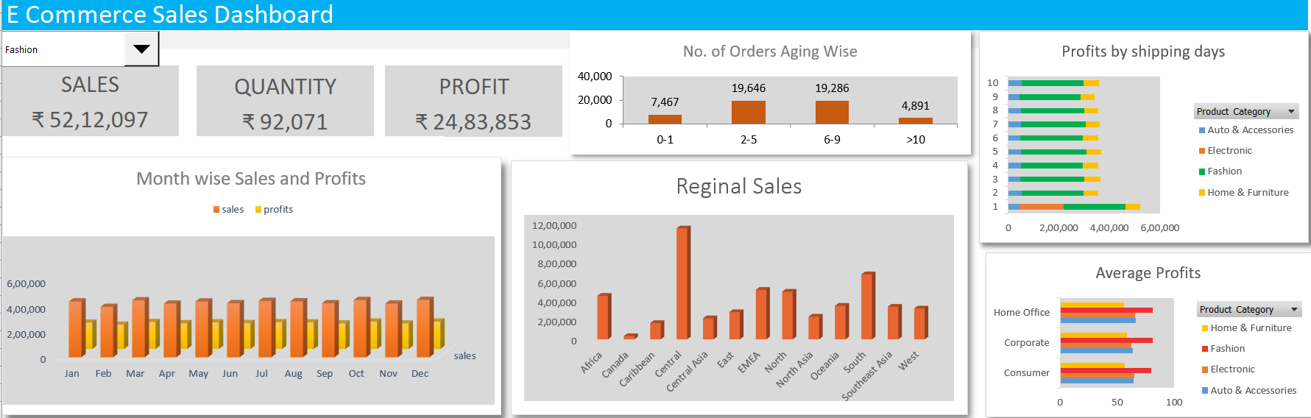

Microsoft Excel is a business intelligence service suite by Microsoft. It is used to convert raw data into meaningful information by using intuitive visualizations and tables. One can easily analyze data and make important business decisions based on it.

**Pros of MS Excel**

**1. Easy and Effective Comparisons**

If you’ve been in the world of business for quite some time, then you would know how frequently comparisons are done every time to understand the change in the[stock market.](https://honestproscons.com/pros-and-cons-of-stock-market-simulator/)

Not just business, professionals working in fields such as psychology, sociology, political science frequently compares the data are gathered to understand the trend in their research such as political data, how caste and income of a family interplayed in the past and now, and so on.

With the powerful analytical tools included, Microsoft Excel offers you the ability to analyze large amounts of data’s the discover the patterns that will influence the conclusion of the work you’ve been doing.

Some tools include data visualization tools such as graphs, histograms, box-plot diagram and so on. These tools help you analyze your data and structure your data accordingly without much complexity of doing them manually with hand and paper.

**2. Accessibility and Collaboration**

With the advent of technology, Microsoft has developed a web version of their applications from the Office Suite package. This allows you to work on the web version of Ms-Excel alongside your peers or colleagues, which technically allows you and your peers to have access to the Excel document from anywhere and manipulate it simultaneously.

Thus, if you’re working on large sets of data and stuck somewhere, then you do not have to wait until the next time to meet your peer or colleague to get help.

Also, Microsoft has developed Excel applications that can be integrated into smartphones such that the user can have access to the Excel file to view, edit and share it.

While Microsoft Excel is updated from time to time, the user might need the latest technology to make the best out of this software. However, this does not restrict the user from running the software on their low powered PC or Laptop.

**3. Data and Analysis**

Excel is a great tool for data analysis not just because we can store our data and perform calculations, but also because of several tools it offers within itself.

Powerful filtering, sorting and search tools enhance user’s ability to efficiently narrowing down the criteria that are taken into consideration in making decisions. Thus, allowing the user to play around with a huge amount of data in an efficient way.

Consequently, the concept of tables, pivot tables, and numerous visualization techniques combined with the above tools can help the user find information that he or she wants promptly despite a huge volume of data items.

**Cons of MS Excel**

**1. Control and Security**

Sometimes the data and information we’re exposed to are huge in size. When the file is too large, it can make the excel program run very slow since the interpreter/compiler needs to go through each and every row and/or column. The easiest way to make sure that excel is time-efficient is by breaking down the file to smaller files. However, this can lead to some of the data’s being lost or misplaced.

Also, Microsoft Excel uses an approximation on very large numbers using imprecise calculations. Thus, this also compromises accuracy and the user barely has control over it since this feature is inbuilt.

So, if there are different people handling the input of same file then the file is susceptible to errors and inaccuracy. These mistakes are not only hard to locate further along the process but can also negatively affect the bottom line.

**2. Data and Growth**

At this point, it is fair to say that Microsoft Excel is an ideal tool for performing a one-time analysis. However, this might not mostly be the case.

Microsoft Excel is prominent in the business world and, with any business, you’re constantly striving to improve. With time, the data grows and evolves. So, you need your data tracking tool to grow with you. However, Excel doesn’t perform better in this front.

To put it in a simple way, the growth of your organization is directly proportional to the number of Excel spreadsheets, which opens out your information further apart. Thus, this makes the organization/user hard to be able to keep up and could possibly lead to bad results and decisions.

**3. Time Inefficiency**

The data does not enter into the spreadsheet. The user has to enter each and every bit of it manually.

Thus, it can take a long time especially if you have a huge amount of data, making Excel inefficient in terms of time efficiency. Also, entering a huge amount of data could potentially lead to errors since most humans can be attentive just for a certain period of time.